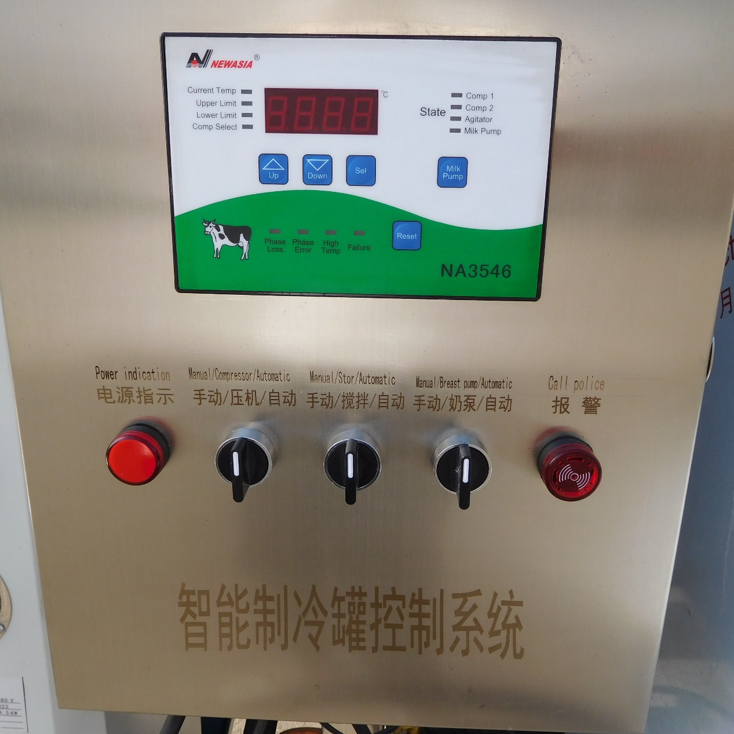
After receiving the device, stabilize it for about 2 hours, then open the electrical control box of the device and start connecting it to the main power supply. The main power supply consists of three live wires and one zero line. The live wire is L and the zero line is N.
After connecting to the main power supply, turn on the air switch and observe whether the computer board alarms for phase mismatch and phase loss,
The picture is as follows：
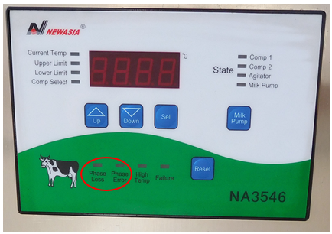
If there is a phase loss alarm, it is necessary to confirm whether the main power supply is incorrect.
If there is a phase error alarm, cut off the main power supply and swap the positions of any two live wires.
The computer board defaults to displaying the temperature inside the can. Once the device phase sequence is confirmed to be correct, the temperature can be set:
First, long press the selection button for about 3 seconds, and the temperature display will flash.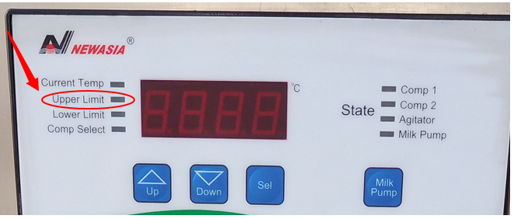
The temperature displayed at this time is the upper temperature limit. Press the set ↑↓ keys to adjust the upper temperature limit. After setting the upper temperature limit, press the selection key once to adjust the lower temperature limit.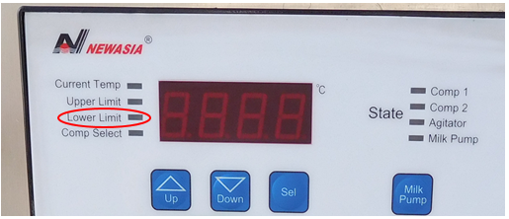
After setting the temperature, press the selection button once to select the compressor option. The default selection is 1. Press the selection button again to save.
Attention: The mixing and compressor need to be turned on simultaneously, and turning on the compressor separately will not work. After the compressor restarts, it has a self-protection function(3minutes). After the second start, the indicator light will turn on when the compressor is turned on. If the compressor does not work, it is considered normal. Automatically start in 3 minutes.

